
a
Company
Logotype

Cone Beam Computed Tomography- Report



Porur Dental X-rays & CBCT

Patient Name : Mr. Sathish Kumar | Date of Report : 16.06.2024
Age/ Gender : 43 years/ Male | Region of Interest : CBCT Full Skull
Referring doctor: Dr. Rajkumar. D | Indication : Implant assessment 17, 27, Impacted teeth 38, 48
Clinical Notes: Nil
PATIENT INFORMATION

CBCT- Full Skull provided
CBCT – IMAGE DETAILS

RADIOGRAPHIC INTERPRETATION

- Completely missing crown and root portion in relation to 17, 18, 28.
- Presence of hyperdense restorative material involving the crown, extending into the pulp canals upto their apical portion in relation to 15, 16, 25, 26.
- The maxillary and mandibular alveolar ridge is present with normal trabecular pattern.
- The long axis of 38, 48 appears to be horizontal/ perpendicular to the long axis of the adjacent teeth.
- The crown of 38 is present such that it appears to be in contact with the distal surface of the root of 37. The root of 38 is present in contact with the Inferior Alveolar nerve canal.
- The crown of 48 is present such that it appears to be in contact with the disto-coronal portion of 47. The root of 48 is present in proximity to the Inferior Alveolar nerve canal.
- Distance between the radicular portion of 38 and the Inferior Alveolar Nerve canal: in contact.
- Distance between the radicular portion of 48 and Inferior Alveolar Nerve canal: 5.3mm.

IMPLANT ASSESSMENT

 | 17 region | 27 region
Sub-Crestal (in mm) | 4.57 | 6.12
Mid- Crestal (in mm) | 6.33 | 7.12
Distance between the alveolar ridge and floor of the maxillary sinus (in mm) | 5.64 | 14.03

RADIOGRAPHIC IMPRESSION

- Partially edentulous maxillary arch.
- Impacted 38, 48.
- Root canal treated teeth: 15,16,25,26.

Kindly correlate with clinical findings


IMAGES FOR REFERENCE

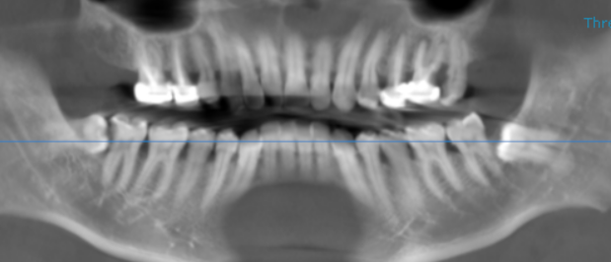

3-DIMENSIONAL VIEW

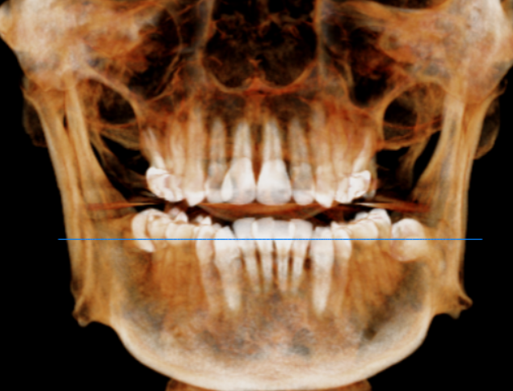

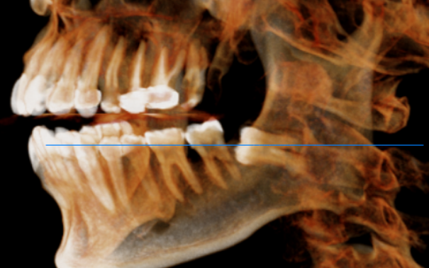
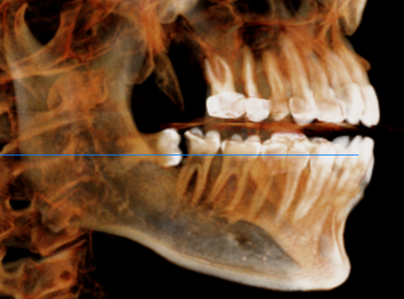

CROSS SECTIONAL VIEW

17 region | 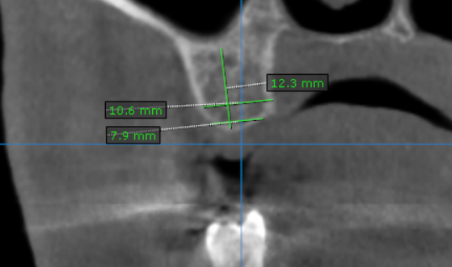
27 region | 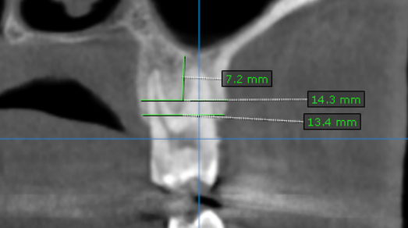
38 region | 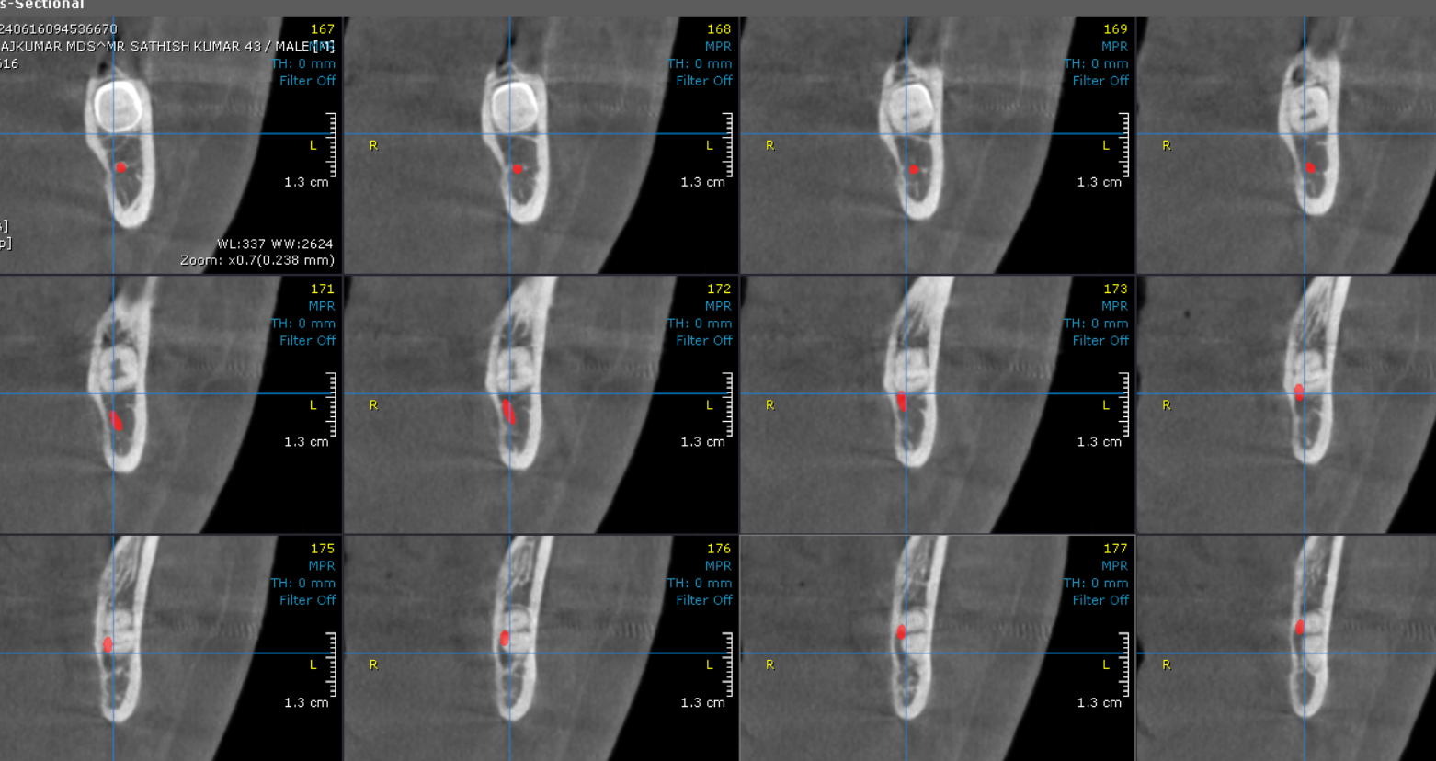
48 region | 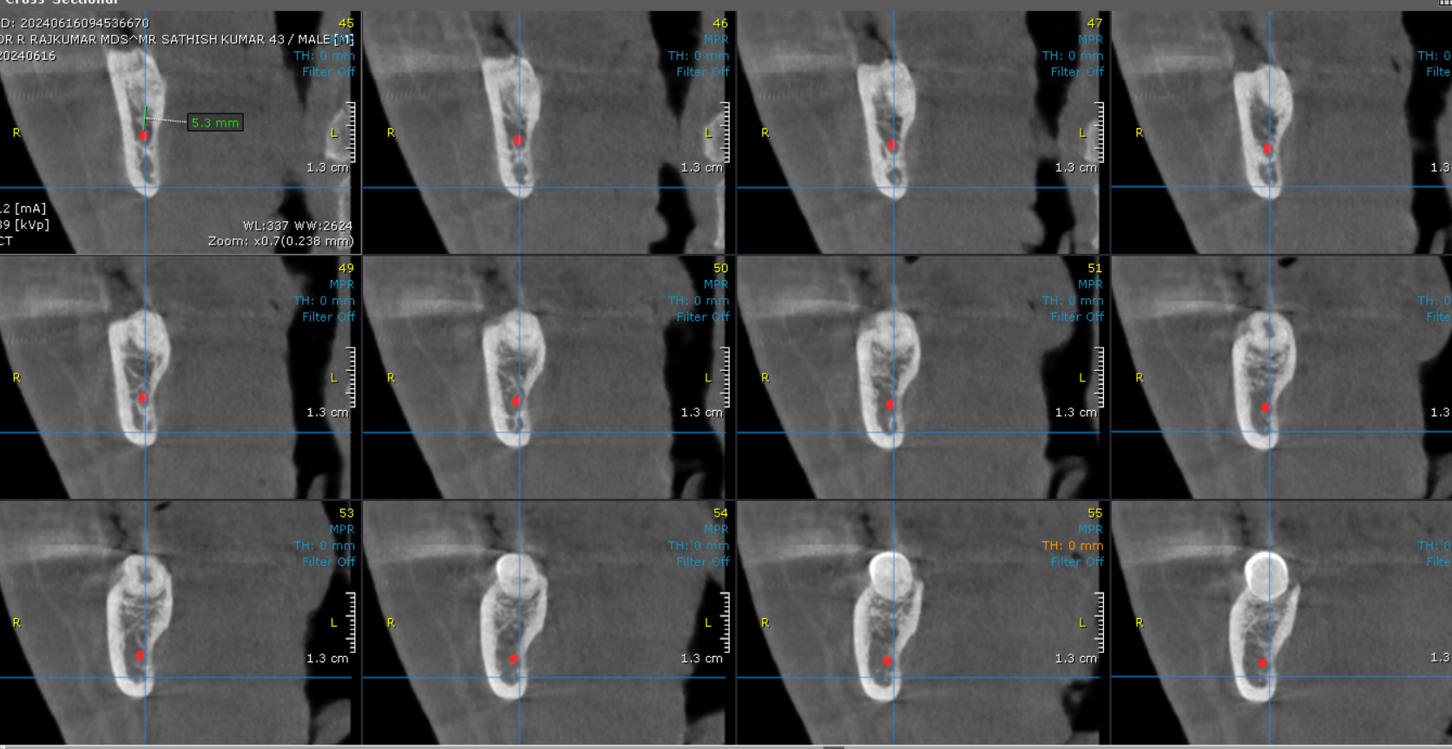

**** End of report ****

